A Project Report on

Banking ATM with PIN security

Submitted in partial fulfillment of requirements for the award of the course
of
EGB1201 – JAVA PROGRAMMING

Under the guidance of

Ms. B. SHARMILADEVI M.E.,



Assistant Professor / EEE

Submitted By

DHANIKESH S (927623BEE017)

DEPARTMENT OF ELECTRICAL AND ELECTRONICS
ENGINEERING

M.KUMARASAMY COLLEGE OF ENGINEERING
(Autonomous)
KARUR – 639 113
DECEMBER 2025

M. KUMARASAMY COLLEGE OF ENGINEERING
(Autonomous Institution affiliated to Anna University, Chennai)

KARUR – 639 113

BONAFIDE CERTIFICATE

Certified that this project report on “Banking ATM with PIN security” is the bonafide work of DHANIKESH S (927624BEE017) who carried out the project work during the academic year 2025–2026 under my supervision.

Signature | Signature
Ms. B. SHARMILADEVI M.E., | Dr. J. Uma M.E.,Ph.D.,
SUPERVISOR, | HEAD OF THE DEPARTMENT,
Department of Electrical and Electronics  Engineering, | Department of Electrical and Electronics  Engineering,
M.Kumarasamy College of Engineering, | M.Kumarasamy College of Engineering,
Thalavapalayam, Karur -639 113. | Thalavapalayam, Karur -639 113.

VISION AND MISSION OF THE INSTITUTION

VISION
• To emerge as a leader among the top institutions in the field of technical education

MISSION
- Produce smart technocrats with empirical knowledge who can surmount the global Challenges.
- Create a diverse, fully-engaged, learner - centric campus environment to provide Quality education to the students.
- Maintain mutually beneficial partnerships with our alumni, industry, and Professional associations.

DEPARTMENT OF ELECTRICAL AND ELECTRONICS
ENGINEERING

VISION
• To create competent Electrical and Electronics Engineers who will work in Emerging technologies thereby contributing value to their career and society

MISSION
- DM1: Impart quality education to enhance knowledge and skills in emerging technologies.
- DM2: Create an innovation and product development ecosystem in core
and Interdisciplinary Industrial applications leading to patents.
- DM3: Augment student core competency and soft skills in handling
technical projects.

PROGRAMME EDUCATIONAL OBJECTIVES (PEOs) • PEO 1 – Core Engineering Proficiency
Apply strong fundamentals in electrical and electronics engineering to solve complex problems in power systems, drives and instrumentation.

• PEO 2 – Research and Emerging Technologies
Pursue research and adopt emerging technologies to innovate in core and interdisciplinary domains.

• PEO 3 – Industry Readiness
Demonstrate technical and professional skills for successful careers in industry and entrepreneurship.

• PEO 4 – Ethics and Societal Responsibility
Practice engineering with ethics, sustainability and a commitment to societal well-being.

• PEO 5 – Lifelong Learning and Global Competence
Engage in continuous learning and adapt to global technological advancements.

PROGRAMME OUTCOMES(POs)
After the successful completion of the B.E. Electrical and Electronics Engineering degree program, the students will be able to:

- PO1 Engineering knowledge: Apply knowledge of mathematics, natural science, computing, engineering fundamentals, and an engineering specialization to develop solutions to complex engineering problems.
- PO2 Problem analysis: Identify, formulate, review research literature and analyze complex engineering problems reaching substantiated conclusions with consideration for sustainable development.
- PO3 Design/development of solutions: Design creative solutions for complex engineering problems and design/develop systems/components/processes to meet identified needs with consideration for the public health and safety, whole-life cost, net zero carbon, culture, society and environment as required.

• PO4 Conduct investigations of complex problems: Conduct
investigations of complex engineering problems using research-based knowledge including design of experiments, modelling, analysis & interpretation of data to provide valid conclusions.
- PO5 Engineering Tool Usage: Create, select and apply appropriate
techniques, resources and modern engineering & IT tools, including prediction and modelling recognizing their limitations to solve complex engineering problems.
- PO6 The Engineer and The World: Analyze and evaluate societal and environmental aspects while solving complex engineering problems for its impact on sustainability with reference to economy, health, safety, legal framework, culture and environment.
- PO7 Ethics: Apply ethical principles and commit to professional ethics, human
values, diversity and inclusion; adhere to national & international laws.
- PO8 Individual and Collaborative Team work: Function effectively as an individual, and as a member or leader in diverse/multi-disciplinary teams.
- PO9 Communication: Communicate effectively and inclusively within the engineering community and society at large, such as being able to comprehend and write effective reports and design documentation, make effective presentations considering cultural, language, and learning differences.

• PO10 Project management and finance: Apply knowledge and
understanding of engineering management principles and economic decisionmaking and apply these to one’s own work, as a member and leader in a team, and to manage projects and in multidisciplinary environments.
• PO11 Life-long learning: Recognize the need for, and have the
preparation and ability for i) independent and life-long learning ii) adaptability to new and emerging technologies and iii) critical thinking in the broadest context of technological change.

PROGRAM SPECIFIC OUTCOMES (PSOs)
The following are the Program Specific Outcomes of Engineering Students:

• PSO 01: Power Systems Engineering
Apply comprehensive knowledge of electrical power systems to analyze, design and manage generation, transmission, and distribution networks, integrating emerging technologies and sustainable practices to contribute effectively to industry and societal needs.

• PSO 02: Power Electronics and Drives
Design and develop efficient, reliable power electronic systems and motor drives with an emphasis on sustainable energy use, and inclusive technology solutions that address societal and environmental challenges.

• PSO 03: Electronics and Instrumentation Engineering
Develop intelligent instrumentation and embedded systems for accurate measurements, monitoring and control in interdisciplinary domains addressing societal needs.

ABSTRACT
The Banking ATM with PIN Security project simulates the working of an Automated Teller Machine (ATM) with secure access using a Personal Identification Number (PIN).The system ensures that only authorized users can perform banking operations such as balance inquiry, cash withdrawal, deposit, and exit.The PIN verification mechanism enhances security by allowing a maximum of three attempts, after which the card is blocked to prevent unauthorized access.This project is implemented in Java, making use of conditional statements, loops, and user input handling for efficient execution.The model demonstrates the integration of basic banking operations with authentication, which is the core principle behind real-world ATM systems

ABSTRACT WITH POs AND PSOs MAPPING

ABSTRACT | POs  MAPPED | PSOs  MAPPED
The Banking ATM with PIN Security project simulates the working of an Automated Teller Machine (ATM) with secure access using a Personal Identification Number (PIN). The system ensures that only authorized users can perform banking operations such as balance inquiry, cash withdrawal, deposit, and exit. The PIN verification mechanism enhances security by allowing a maximum of three attempts, after which the card is blocked to prevent unauthorized access. This project is implemented in Java, making use of conditional statements, loops, and user input handling for efficient execution. The model demonstrates the integration of basic banking operations with authentication | PO1  PO2  PO3  PO4  PO5  PO6  PO7  PO8  PO9  PO10  PO11  PO12
Note: 1- Low, 2-Medium, 3- High

SUPERVISOR HEAD OF THE DEPARTMENT

TABLE OF CONTENTS
CHAPTER  No. | TITLE | PAGE  No.
 | ABSTRACT
1 | INTRODUCTION
 | 1.1 Objective | 1
 | 1.2 Overview | 1
 | 1.3 Java Programming concepts | 2
2 | PROJECT METHODOLOGY
 | 2.1Proposed Work | 2
 | 2.2 Block Diagram | 3
3 | MODULE DESCRIPTION
 | 3.1 User Input Module | 3
 | 3.2 Authentication Module (PIN Verification) | 3
 | 3.3 ATM Menu Module | 4
 | 3. Banking Operations Module | 4
 | 3.5 Attempt Count & Locking Module | 5
4 | RESULTS AND DISCUSSION | 6
5 | CONCLUSION | 7
 | REFERENCES | 7
 | APPENDIX | 8-17

CHAPTER 1
INTRODUCTION

1.1 Objective

The objective of this project is to develop a secure and user-friendly ATM Banking System in Java that simulates real ATM operations, allowing users to log in using a PIN, check balance, withdraw cash, deposit money, and change their PIN. The project aims to demonstrate the implementation of core banking functions through a console-based interface while ensuring security using a three-attempt PIN lockout system. It also focuses on applying Object-Oriented Programming (OOP) principles to create a modular, efficient, and maintainable application that represents real-world ATM behavior in a simplified manner.

1.2 Overview

This project presents a Java-based ATM system that simulates the essential functions of a real Automated Teller Machine, including secure user authentication and basic banking transactions. The system allows users to log in with their account number and PIN, and once authenticated, they can perform operations such as checking balance, withdrawing funds, depositing money, and changing their PIN. It incorporates a simple but effective security mechanism that locks the account after three incorrect PIN attempts, ensuring protection against unauthorized access. The project showcases the use of object-oriented concepts such as classes, objects, encapsulation, and modular design to create a structured and maintainable application, while offering a realistic understanding of how ATM software operates internally.

1.3 Java Programming Concepts

This project makes use of several core Java programming concepts that help build a secure, structured, and efficient ATM system. Object-Oriented Programming (OOP) concepts such as classes, objects, encapsulation, and abstraction are used to model realworld entities like accounts and the ATM machine. Constructors and methods are applied to initialize data and perform operations such as login, withdrawal, and deposit. Control structures—including loops, conditionals, and switch statements—manage user interactions and program flow. Exception handling concepts ensure smooth execution by preventing errors during invalid inputs. Additionally, Java’s standard library classes like Scanner are used for user input, while access modifiers and data hiding help protect sensitive information such as PINs and account balances. Together, these concepts make the system modular, reusable, and easy to maintain.

CHAPTER 2

PROJECT METHODOLOGY

2.1 Proposed Work

The proposed work involves developing a secure and interactive Java-based ATM system that simulates real banking operations while ensuring user data safety and system reliability. The system will allow users to authenticate themselves using an account number and PIN, followed by access to key ATM features such as balance inquiry, cash withdrawal, deposit, and PIN change. To enhance security, the system will include a three-attempt PIN validation mechanism that automatically locks the account after repeated failures. The software will be designed using Object-Oriented Programming principles to ensure modularity, maintainability, and scalability. Additionally, the project aims to create a smooth console-based user interface and maintain accurate transaction handling, ultimately providing a functional prototype of an ATM machine suitable for learning, demonstration, and further enhancements.

2.2 Block Diagram
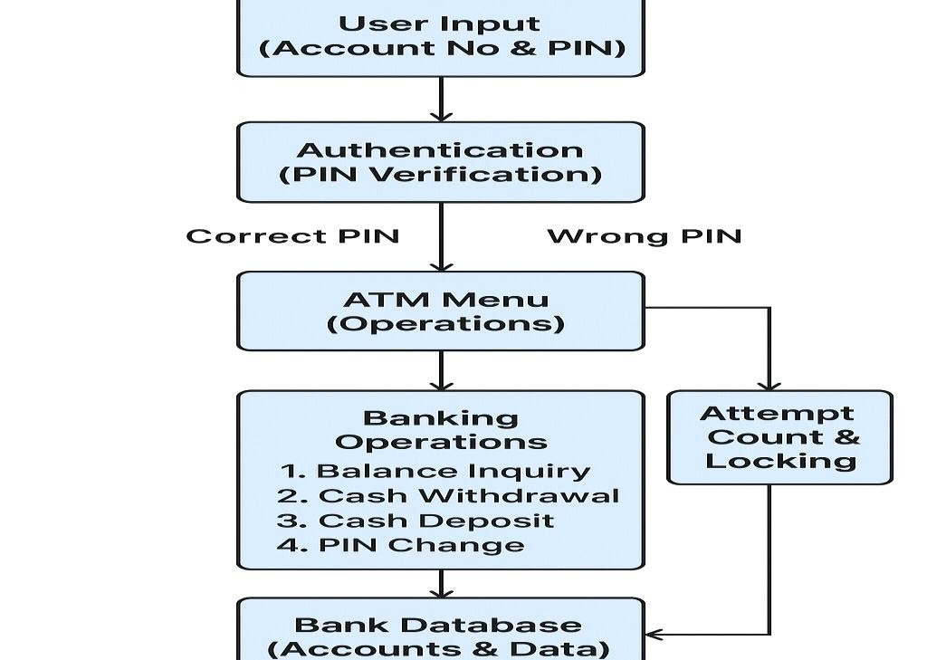

CHAPTER 3

MODULE DESCRIPTION

3.1 Module User Input (Expanded Explanation)
. Good user input handling prevents errors and enhances This module acts as the first point interaction between the user and the ATM system. It captures essential inputs such as the account number, PIN, and menu choices. It also validates input format, checks for empty values, and ensures the data is passed securely to the authentication moduleusability.

3.2 Module Authentication (PIN Verification)
This is one of the most critical security components. After receiving the user input, it retrieves the stored PIN from the database, compares it securely (often using hashing), and decides whether to allow or deny access. It also communicates with the Attempt Count Module to track failed attempts. A strong authentication module prevents unauthorized access to bank accounts.

3.3 Module ATM Menu
Once authentication succeeds, the system loads this module to present the available services:
- Balance Inquiry
- Withdrawal
- Deposit
- PIN Change
- Mini Statement
This module ensures the user sees a clear, simple menu and can navigate easily. It often runs in a loop until the user chooses to exit. The design of this module directly affects usability and user experience.

3.4Module Banking Operations

This module contains the core banking functions. It processes each operation as requested by the user:
- Withdrawal: verifies sufficient funds, dispenses cash, and updates balance
- Deposit: updates balance after the user deposits an amount
- Balance Inquiry: retrieves and displays the current balance
- PIN Change: updates user credentials securely
It communicates heavily with the Bank Database Module to ensure accurate and realtime updates.

3.5Module Attempt Count & Locking

This module safeguards the ATM from brute-force attacks.It performs the following tasks:
- Tracks how many times an incorrect PIN is entered
- Allows a maximum of 3 attempts
- Automatically locks the account upon exceeding the limit
- Alerts the authentication module about lock status
By adding this module, the system becomes more secure and prevents unauthorized access to user accounts.

CHAPTER 4

RESULTS AND DISCUSSION
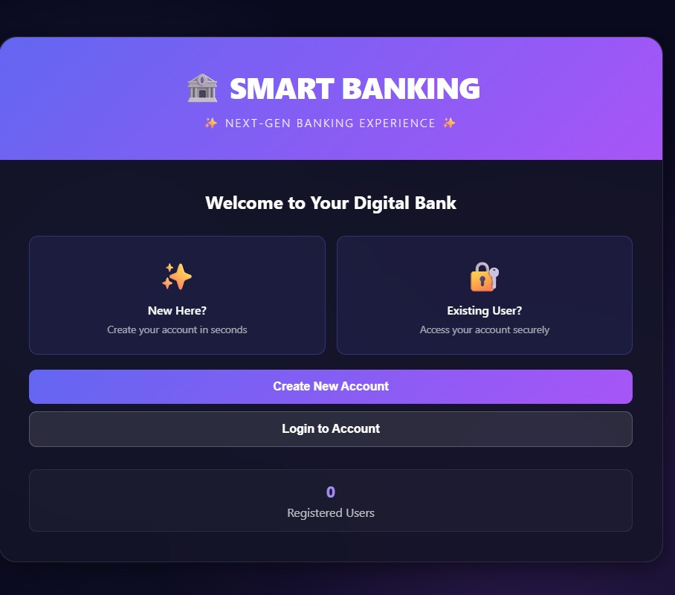

The Smart Banking interface presents a clean and modern design with a strong visual hierarchy that highlights key actions such as creating a new account or logging in. The purple gradient header, icons, and structured layout create an inviting and intuitive user experience suitable for a digital banking platform. It effectively separates new and existing user flows, making onboarding simple, while the registered user counter adds a dynamic system touch. However, the UI could be improved with additional explanatory text to build user trust, enhanced accessibility features for readability, and engagement elements like security badges or brief feature descriptions to strengthen credibility.

CHAPTER 5
CONCLUSION

The Java-based ATM System with PIN security successfully demonstrates how core banking operations can be simulated using fundamental programming concepts and modular software design. The project meets its objectives by providing secure user authentication, reliable transaction handling, and a structured workflow through welldefined modules such as authentication, menu navigation, banking operations, and account locking. The system performs efficiently during testing, accurately managing user inputs and maintaining data integrity in all transactions. Overall, this project highlights the effectiveness of Java in building secure, scalable, and user-friendly applications, while also showcasing the importance of modular design, error handling, and security mechanisms in financial software development. With further enhancements such as GUI interfaces, encryption, and real database integration, the system can evolve into a more advanced and realistic ATM simulation.

REFERENCES:

- Herbert Schildt, Java: The Complete Reference, McGraw-Hill Education, 11th Edition.
- E. Balagurusamy, Programming with Java, McGraw-Hill Education.
- Oracle Java Documentation – https://docs.oracle.com/javase
- Deitel & Deitel, Java How to Program, Pearson Education.
- IEEE Papers on ATM Security and Authentication Systems.
- TutorialsPoint – Java Programming Guide.
- GeeksforGeeks – Java OOP Concepts and Examples.
- Studytonight – Java Classes, Objects, and Exception Handling.

APPENDIX

(Coding)

import java.util.*;
import java.time.LocalDateTime;
import java.time.format.DateTimeFormatter;

// Transaction Class
class Transaction {
private String type;
private double amount;
private String date;
private double balanceAfter;

public Transaction(String type, double amount, double balanceAfter) {
this.type = type;
this.amount = amount;
this.balanceAfter = balanceAfter;
DateTimeFormatter formatter = DateTimeFormatter.ofPattern("dd-MM-yyyy HH:mm:ss");
this.date = LocalDateTime.now().format(formatter);
}

public String getType() { return type; }
public double getAmount() { return amount; }
public String getDate() { return date; }
public double getBalanceAfter() { return balanceAfter; }

@Override
public String toString() {
return type + " | Amount: ₹" + String.format("%.2f", amount) +
" | Date: " + date + " | Balance: ₹" + String.format("%.2f", balanceAfter);
}
}

// Login Record Class
class LoginRecord {
private String accountNumber;
private String name;
private String loginTime;

public LoginRecord(String accountNumber, String name) {
this.accountNumber = accountNumber;
this.name = name;
DateTimeFormatter formatter = DateTimeFormatter.ofPattern("dd-MM-yyyy HH:mm:ss");
this.loginTime = LocalDateTime.now().format(formatter);
}

public String getAccountNumber() { return accountNumber; }
public String getName() { return name; }
public String getLoginTime() { return loginTime; }

@Override
public String toString() {
return "Account: " + accountNumber + " | Name: " + name + " | Login Time: " + loginTime;
}
}

// Bank Account Class
class BankAccount {
private String name;
private String dob;
private String accountType;
private String accountNumber;
private String pin;
private double balance;
private List<Transaction> transactions;

public BankAccount(String name, String dob, String accountType,
String accountNumber, String pin, double initialDeposit) {
this.name = name;
this.dob = dob;
this.accountType = accountType;
this.accountNumber = accountNumber;
this.pin = pin;
this.balance = initialDeposit;
this.transactions = new ArrayList<>();
this.transactions.add(new Transaction("Initial Deposit", initialDeposit, balance));
}

public String getName() { return name; }
public String getDob() { return dob; }
public String getAccountType() { return accountType; }
public String getAccountNumber() { return accountNumber; }
public String getPin() { return pin; }
public double getBalance() { return balance; }
public List<Transaction> getTransactions() { return transactions; }

public void deposit(double amount) {
balance += amount;
transactions.add(new Transaction("Deposit", amount, balance));
}

public boolean withdraw(double amount) {
if (amount > balance) return false;
balance -= amount;
transactions.add(new Transaction("Withdrawal", amount, balance));
return true;
}

public void displayAccountInfo() {
System.out.println("\nACCOUNT INFORMATION");
System.out.println("Account Number: " + accountNumber);
System.out.println("Name: " + name);
System.out.println("Account Type: " + accountType);
System.out.println("Date of Birth: " + dob);
System.out.println("Balance: ₹" + String.format("%.2f", balance));
}

public void displayTransactions() {
System.out.println("\nTRANSACTION HISTORY");
if (transactions.isEmpty()) {
System.out.println("No transactions found.");
} else {
for (int i = transactions.size() - 1; i >= 0; i--) {
System.out.println(transactions.get(i).toString());
}
}
}
}

// Main Banking System Class
public class SmartBankingSystem {
private static Map<String, BankAccount> bankDatabase = new HashMap<>();
private static List<LoginRecord> loginHistory = new ArrayList<>();
private static Scanner scanner = new Scanner(System.in);

private static final String ADMIN_USERNAME = "admin";
private static final String ADMIN_PASSWORD = "admin123";

private static Map<String, Double> accountTypeMinDeposits = new HashMap<>();

static {
accountTypeMinDeposits.put("1", 500.0);
accountTypeMinDeposits.put("2", 0.0);
accountTypeMinDeposits.put("3", 0.0);
accountTypeMinDeposits.put("4", 100.0);
accountTypeMinDeposits.put("5", 500.0);
}

public static void main(String[] args) {
System.out.println("WELCOME TO SMART BANKING SYSTEM");

while (true) {
showMainMenu();
}
}

private static void showMainMenu() {
System.out.println("\nMAIN MENU");
System.out.println("1. Create New Account");
System.out.println("2. User Login");
System.out.println("3. Admin Login");
System.out.println("4. Exit");
System.out.print("Enter your choice: ");

String choice = scanner.nextLine();

switch (choice) {
case "1": createAccount(); break;
case "2": userLogin(); break;
case "3": adminLogin(); break;
case "4":
System.out.println("Thank you for using Smart Banking System!");
System.exit(0);
default:
System.out.println("Invalid choice!");
}
}

private static void createAccount() {
System.out.println("\nCREATE NEW ACCOUNT");

System.out.print("Enter Full Name: ");
String name = scanner.nextLine();

System.out.print("Enter Date of Birth (DD-MM-YYYY): ");
String dob = scanner.nextLine();

System.out.println("Select Account Type:");
System.out.println("1. Savings Account (Min: ₹500)");
System.out.println("2. Zero Balance Account (Min: ₹0)");
System.out.println("3. Salary Account (Min: ₹0)");
System.out.println("4. Student Scholarship Account (Min: ₹100)");
System.out.println("5. Current Account (Min: ₹500)");
System.out.print("Enter choice: ");
String typeChoice = scanner.nextLine();

String accountType = getAccountTypeName(typeChoice);
if (accountType == null) {
System.out.println("Invalid account type!");
return;
}

System.out.print("Enter Account Number: ");
String accountNumber = scanner.nextLine();

if (bankDatabase.containsKey(accountNumber)) {
System.out.println("Account already exists!");
return;
}

double minDeposit = accountTypeMinDeposits.get(typeChoice);
System.out.print("Enter Initial Deposit (Min ₹" + minDeposit + "): ");
double initialDeposit = Double.parseDouble(scanner.nextLine());

if (initialDeposit < minDeposit) {
System.out.println("Deposit below minimum!");
return;
}

System.out.print("Create 4-digit PIN: ");
String pin = scanner.nextLine();

if (!pin.matches("\\d{4}")) {
System.out.println("PIN must be 4 digits!");
return;
}

BankAccount account = new BankAccount(name, dob, accountType, accountNumber, pin, initialDeposit);
bankDatabase.put(accountNumber, account);

System.out.println("Account Created Successfully!");
}

private static void userLogin() {
System.out.println("\nUSER LOGIN");

System.out.print("Enter Account Number: ");
String accountNumber = scanner.nextLine();

System.out.print("Enter PIN: ");
String pin = scanner.nextLine();

BankAccount account = bankDatabase.get(accountNumber);

if (account == null || !account.getPin().equals(pin)) {
System.out.println("Invalid login!");
return;
}

loginHistory.add(new LoginRecord(accountNumber, account.getName()));

System.out.println("Login Successful!");
userDashboard(account);
}

private static void userDashboard(BankAccount account) {
while (true) {
account.displayAccountInfo();
System.out.println("\nUSER DASHBOARD");
System.out.println("1. Deposit Money");
System.out.println("2. Withdraw Money");
System.out.println("3. View Transaction History");
System.out.println("4. Logout");
System.out.print("Enter your choice: ");

String choice = scanner.nextLine();

switch (choice) {
case "1": depositMoney(account); break;
case "2": withdrawMoney(account); break;
case "3": account.displayTransactions(); break;
case "4": return;
default: System.out.println("Invalid choice!");
}
}
}

private static void depositMoney(BankAccount account) {
System.out.println("\nDEPOSIT MONEY");
System.out.print("Enter amount (Min ₹100): ");
double amount = Double.parseDouble(scanner.nextLine());

if (amount < 100) {
System.out.println("Minimum deposit is ₹100.");
return;
}

System.out.print("Enter PIN: ");
String pin = scanner.nextLine();

if (!pin.equals(account.getPin())) {
System.out.println("Incorrect PIN!");
return;
}

account.deposit(amount);
System.out.println("Deposit Successful!");
}

private static void withdrawMoney(BankAccount account) {
System.out.println("\nWITHDRAW MONEY");
System.out.print("Enter amount (Min ₹100): ");
double amount = Double.parseDouble(scanner.nextLine());

if (amount < 100) {
System.out.println("Minimum withdrawal is ₹100.");
return;
}

System.out.print("Enter PIN: ");
String pin = scanner.nextLine();

if (!pin.equals(account.getPin())) {
System.out.println("Incorrect PIN!");
return;
}

if (account.withdraw(amount)) {
System.out.println("Withdrawal Successful!");
} else {
System.out.println("Insufficient balance!");
}
}

private static void adminLogin() {
System.out.println("\nADMIN LOGIN");

System.out.print("Enter Username: ");
String username = scanner.nextLine();

System.out.print("Enter Password: ");
String password = scanner.nextLine();

if (username.equals(ADMIN_USERNAME) && password.equals(ADMIN_PASSWORD)) {
adminDashboard();
} else {
System.out.println("Invalid credentials!");
}
}

private static void adminDashboard() {
while (true) {
System.out.println("\nADMIN DASHBOARD");
System.out.println("1. View All Users");
System.out.println("2. View Login History");
System.out.println("3. View User Transaction History");
System.out.println("4. View All Transactions");
System.out.println("5. Logout");
System.out.print("Enter choice: ");

String choice = scanner.nextLine();

switch (choice) {
case "1": viewAllUsers(); break;
case "2": viewLoginHistory(); break;
case "3": viewUserTransactionHistory(); break;
case "4": viewAllTransactions(); break;
case "5": return;
default: System.out.println("Invalid choice!");
}
}
}

private static void viewAllUsers() {
System.out.println("\nALL REGISTERED USERS");

if (bankDatabase.isEmpty()) {
System.out.println("No users found!");
return;
}

for (BankAccount acc : bankDatabase.values()) {
System.out.println(acc.getAccountNumber() + " | " + acc.getName() +
" | " + acc.getAccountType() + " | ₹" + acc.getBalance());
}
}

private static void viewLoginHistory() {
System.out.println("\nLOGIN HISTORY");

if (loginHistory.isEmpty()) {
System.out.println("No login history found!");
return;
}

for (LoginRecord lr : loginHistory) {
System.out.println(lr.toString());
}
}

private static void viewUserTransactionHistory() {
System.out.print("\nEnter Account Number: ");
String accNo = scanner.nextLine();

BankAccount acc = bankDatabase.get(accNo);

if (acc == null) {
System.out.println("Account not found!");
return;
}

acc.displayTransactions();
}

private static void viewAllTransactions() {
System.out.println("\nALL TRANSACTIONS");

int total = 0;

for (BankAccount acc : bankDatabase.values()) {
System.out.println("\nAccount: " + acc.getAccountNumber() + " | " + acc.getName());
for (Transaction t : acc.getTransactions()) {
System.out.println(t.toString());
total++;
}
}

System.out.println("\nTotal Transactions: " + total);
}

private static String getAccountTypeName(String choice) {
switch (choice) {
case "1": return "Savings Account";
case "2": return "Zero Balance Account";
case "3": return "Salary Account";
case "4": return "Student Scholarship Account";
case "5": return "Current Account";
default: return null;
}
}
}

